AI-Powered Job Market Analytics and Skill Demand Forecasting Dashboard

An Industry Oriented Mini Project Report

Submitted to



Jawaharlal Nehru Technological University Hyderabad
In partial fulfilment of the requirements for the

award of the degree of

BACHELOR OF TECHNOLOGY
in
CSE (Artificial Intelligence & Machine Learning)

By
KATARAM NAVYA SREE (23VE1A66G2)
KOKILA SUMITH KUMAR (23VE1A66J5)
THANNIRU USHA RANI (23VE1A66J8)
DUGGIRALA CHARAN (23VE1A66E7)

Under the Guidance of
Dr Devineni Gireesh Kumar,
Associate Professor


DEPARTMENT OF CSE (Artificial Intelligence & Machine Learning)
Approved by AICTE, New Delhi | Affiliated to JNTUH, Hyderabad | Accredited by NAAC “A” Grade & NBA| Hyderabad | PIN: 500068
(2023 – 2027)

DEPARTMENT OF CSE (Artificial Intelligence & Machine Learning)
Approved by AICTE, New Delhi | Affiliated to JNTUH, Hyderabad | Accredited by NAAC “A” Grade & NBA| Hyderabad | PIN: 500068
(2023-2027)

Certificate

This is to certify that the Industry Oriented Mini Project Report on “AI-Powered Job Market Analytics and Skill Demand Forecasting Dashboard” submitted by Kataram Navya Sree, Kokila Sumith Kumar, Thanniru Usha Rani, Duggirala Charan bearing Hall Ticket No’s. 23VE1A66G2, 23VE1A66J5, 23VE1A66J8, 23VE1A66E7 in partial fulfilment of the requirements for the award of the degree of Bachelor of Technology in CSE (Artificial Intelligence & Machine Learning) from Jawaharlal Nehru Technological University, Kukatpally, Hyderabad, for the academic year 2025-26 is a record of bona fide work carried out by him/her under our guidance and Supervision.

Guide Head of the Department

Dr Devineni Gireesh Kumar, Dr A. Swathi
Associate Professor

Project Coordinator Signature of the External Examiner


DEPARTMENT OF CSE (Artificial Intelligence & Machine Learning)
Approved by AICTE, New Delhi | Affiliated to JNTUH, Hyderabad | Accredited by NAAC “A” Grade & NBA| Hyderabad | PIN: 500068
(2023-2027)

DECLARATION

We, Kataram Navya Sree, Kokila Sumith Kumar, Thanniru Usha Rani, Duggirala Charan bearing 23VE1A66G2, 23VE1A66J5, 23VE1A66J8, 23VE1A66E7 hereby declare that the Project titled “AI-Powered Job Market Analytics and Skill Demand Forecasting Dashboard” done by us under the guidance of Dr Devineni Gireesh Kumar, which is submitted in the partial fulfillment of the requirement for the award of the B.Tech degree in CSE (Artificial Intelligence & Machine Learning) for Jawaharlal Nehru Technological University, Hyderabad is our original work.

Kataram Navya Sree (23VE1A66G2)
Kokila Sumith Kumar(23VE1A66J5)
Thanniru Usha Rani (23VE1A66J8)
Duggirala Charan (23VE1A66E7)

ACKNOWLEDGEMENT

The successful completion of any task would be incomplete without mention of the people who made it possible through their guidance and encouragement crowns all the efforts with success.
We take this opportunity to acknowledge with thanks and a deep sense of gratitude Dr A. Swathi, Associate Professor and Head of the Department, for her constant encouragement and valuable guidance during this work.
A Special note of Thanks to Dr Devineni Gireesh Kumar, Guide, Associate Professor, who has been a source of Continuous motivation and support in the completion of this project. She has taken time and effort to guide and correct us all through the span of this work.
We owe very much to the Department Faculty, Principal and the Management who made our term at SREYAS Institute of Engineering & Technology a Stepping stone for our career. We treasure every moment we spent in college.
Last but not least, our heartiest gratitude to our parents and friends for their continuous encouragement and blessings. Without their support, this work would not have been possible.

Kataram Navya Sree (23VE1A66G2)
Kokila Sumith Kumar (23VE1A66J5)
Thanniru Usha Rani(23VE1A66J8)
Duggirala Charan(23VE1A66E7)

ABSTRACT

The rapid growth of Artificial Intelligence and digital technologies has significantly changed the global job market. Organizations continuously seek professionals with updated technical skills, making it difficult for students and job seekers to understand which skills will be most valuable in the future. Traditional job analysis methods mainly focus on historical data and lack the ability to accurately forecast future skill demand. The system utilizes a Job Market Dataset (job_market_dataset.csv) comprising approximately 15,000+ job postings collected from publicly available job portals across multiple countries and industries. The dataset includes attributes such as job title, skills, salary (USD), experience level, company location, industry, and remote work ratio. Machine learning models, including Linear Regression, Random Forest Regressor, and ARIMA, are implemented and comparatively evaluated for Skill Demand Forecasting. Experimental results indicate that the Random Forest model achieved the highest performance with an accuracy of approximately 91%, outperforming Linear Regression (72%) and ARIMA (85%), with lower prediction errors (RMSE ≈ 4.1 and MAE ≈ 2.7). The proposed AI-based Career Guidance System integrates data preprocessing, feature engineering, and predictive modelling with an interactive Streamlit-based dashboard. The key novelty lies in the integration of Skill Demand Forecasting with AI-driven career guidance features, including skill gap detection, job role prediction, and personalized learning roadmaps. The results demonstrate that the system effectively performs Skill Demand Forecasting and supports data-driven career decision-making.

Keywords:
Artificial Intelligence (AI), Job Market Analytics, Skill Demand Forecasting, Machine Learning, Data Analytics, Predictive Analysis, Job Trend Analysis, Data Visualization, AI-based Career Guidance System

TABLE OF CONTENTS

CONTENTS | PAGE NO
Abstract | i
List of figures | iv
List of tables | v
CHAPTER 1: INTRODUCTION | 1-4
1.1 Introduction | 1-2
1.2 Motivation | 2-3
1.3 Objective | 3
1.4 Scope of the Project | 3-4
CHAPTER 2: LITERATURE SURVEY | 5-13
2.1 Introduction | 5
2.2 Job Market Analysis using AI & ML | 6-7
2.3 Data Analytics in Employment Trends | 7-8
2.4 Skill Demand Prediction Techniques | 8
2.5 Future Developments | 8-9
2.6 Literature Review Summary | 9-13
CHAPTER 3: SYSTEM DESIGN | 14-21
3.1 System Architecture | 14-15
3.2 Dataset Description | 15-16
3.3 Data Preprocessing | 16-17
3.4 Model Design | 17-19
3.5 Training Procedure | 19
3.6 Evaluation Metrics | 19-20
3.7 System Workflow Algorithm | 20-21
CHAPTER 4: Implementation | 22-27
4.1 Software Requirements | 22
4.2 Hardware Requirements  4.3 Module-wise Implementation | 22-23  23-24
4.4 Code | 24-27
CHAPTER 5: RESULTS AND DISCUSSION | 28-33
5.1 Output  5.2 Experimental Setup | 28-32  32-33
5.3 Performance Analysis | 33
5.4 Discussion | 33
CHAPTER 6: APPLICATIONS AND SOCIETAL IMPACT | 34-36
6.1 Advantages | 34
6.2 Applications | 34-35
6.3 Societal Impact / SDGs | 35-36
CHAPTER 7: CONCLUSION AND FUTURE SCOPE | 37-38
CHAPTER 8: REFERENCES | 39-40

LIST OF FIGURES

FIG.NO | NAME OF THE FIGURE | PAGE.NO
1 | System Architecture Diagram | 15
2 | Dashboard Interface | 28
3 | Global Job Demand and Industry Distribution | 28
4 | Skill Demand Forecasting | 29
5 | Skill Growth Rate | 29
6 | Future Job Trends | 30
7 | Skill Demand Analysis | 30
8 | Skill Gap Analysis | 31
9 | Dataset Overview | 31
10 | AI Career Chatbot and User Feedback | 32

LIST OF TABLES

TABLE.NO | NAME OF THE TABLE | PAGE.NO
1 | Dataset Description | 15
2 | Data Preprocessing Steps | 16
3 | Feature Selection Attributes | 19
4 | Literature Review Summary | 9
5 | Comparison of Existing Systems | 23
6 | Research Gap Analysis | 24
7 | Most In-Demand Skills | 26
8 | Job Roles Distribution | 28
9 | Skill Demand Forecasting | 29
10 | Model Performance Metrics | 33

CHAPTER 1
INTRODUCTION

1.1 Introduction
In recent years, the rapid growth of digital technologies and Artificial Intelligence has significantly transformed the global job market. New technologies such as cloud computing, data science, machine learning, and cybersecurity are continuously creating new job roles while changing the skill requirements of existing jobs. As a result, both students and job seekers often find it difficult to understand which skills are currently in demand and which skills will be important in the future. Organizations also face challenges in identifying talent with the right set of skills to meet evolving industry requirements.
Traditional job market analysis methods mainly depend on historical reports, surveys, or manual observations. These approaches are often time-consuming and do not provide real-time insights or accurate predictions about future job trends. With the increasing availability of large-scale job posting data on online platforms, there is an opportunity to use advanced data analytics and artificial intelligence techniques to analyze these datasets and extract valuable insights.
The AI-Powered Job Market Analytics and Skill Demand Forecasting Dashboard is designed to address these challenges by providing an intelligent system that analyzes job market data and predicts future skill demands. The system collects job posting information such as job roles, required skills, experience levels, and locations from structured datasets. Data preprocessing techniques are applied to clean and organize the data before analysis. Machine learning algorithms are then used to identify patterns, analyze hiring trends, and forecast the demand for various skills and technologies.
The proposed system also includes an interactive dashboard that visually presents the analysis results using graphs, charts, and statistical summaries. This dashboard allows users to easily explore job market trends, identify the most demanded skills, and understand how skill requirements are evolving
over time. By providing clear and data-driven insights, the system helps students plan their learning paths, assists job seekers in improving their employability, and enables educational institutions to update their curriculum according to industry needs.
Overall, the project demonstrates the potential of artificial intelligence and data analytics in transforming raw job market data into meaningful insights and future predictions. By forecasting skill demand and presenting information through an interactive dashboard, the system aims to bridge the gap between industry requirements and workforce skills, supporting better career planning and workforce development.
1.2 Motivation
The job market is rapidly evolving due to the growth of digital technologies, automation, and Artificial Intelligence. New technologies such as data science, cloud computing, machine learning, and cybersecurity are creating new career opportunities while also changing the skills required for existing jobs. However, many students and job seekers struggle to understand which skills are currently in demand and which skills will be important for future careers. This gap between industry requirements and the skills possessed by job seekers often leads to unemployment or underemployment.
Another major challenge is the lack of accessible tools that can analyze large amounts of job market data and present meaningful insights in a simple way. Job postings contain valuable information about required skills, job roles, and industry trends, but this data is often scattered across multiple platforms and difficult to analyze manually. Without proper analysis, individuals and educational institutions may not be able to make informed decisions about career development or curriculum planning.
The motivation behind this project is to develop an intelligent system that can analyze job market data using Artificial Intelligence and machine learning techniques. By building an AI-Powered Job Market Analytics and Skill Demand Forecasting Dashboard, the project aims to identify trending skills, analyze hiring patterns, and predict future skill demand. The system also provides visual insights through an interactive dashboard, making complex data easy to understand.
This project is motivated by the need to support students, job seekers, educators, and organizations in making better career and workforce decisions. By providing data-driven insights about job market trends and future skill requirements, the system helps bridge the gap between education and industry needs, ultimately improving employability and career planning.
1.3 Objective
- To collect and analyze job market data from various job postings
The first objective of this project is to gather job-related data from different online job platforms or datasets. The collected data may include job titles, required skills, company names, experience levels, salary ranges, and locations. This information is essential for understanding the structure of the job market. By analyzing this data, the system can identify patterns and trends related to employment opportunities in different industries.
- To identify the most in-demand skills and technologies in the current job market
Another important objective is to determine which technical and professional skills are currently most demanded by employers. The system analyzes job postings to find frequently mentioned skills such as programming languages, software tools, and technical competencies. This helps in identifying trending technologies like data science, artificial intelligence, cloud computing, and cybersecurity.
- To develop a machine learning model to predict future skill demand
One of the main goals of the project is to forecast future skill demand using machine learning algorithms. The model analyzes historical job data to understand patterns in hiring trends. Based on these patterns, the system can predict which skills are likely to become more important in the future. This prediction helps individuals and organizations prepare for upcoming changes in the job market.

1.4 Scope of the Project
- Job Market Data Collection
The project focuses on collecting job-related data from available datasets or job portals. This data may include job titles, required skills, experience levels, company names, and job locations. Collecting such information helps in understanding the structure of the job market and provides the base for further analysis.
- Data Preprocessing and Cleaning
The collected job data may contain missing values, duplicate records, or inconsistent formats. Therefore, data preprocessing is performed to clean and organize the dataset. This step improves the quality of the data and ensures accurate analysis and reliable results.
- Job Market Trend Analysis
The system analyzes the cleaned dataset to identify current hiring trends. It studies which job roles are most common and which industries are offering more opportunities. This analysis helps in understanding the present condition of the job market.
- Identification of In-Demand Skills
The project aims to identify the most demanded skills and technologies required by employers. By analyzing job postings, the system highlights popular skills such as programming languages, software tools, and technical competencies that are frequently required in different job roles.
- Skill Demand Forecasting
The system uses machine learning techniques to predict future skill demand based on historical job market data. By analyzing past hiring patterns, the model can estimate which skills may become more important in the future.
- Interactive Dashboard Visualization
The project includes the development of a user-friendly dashboard that presents job market insights through graphs, charts, and tables. This visualization helps users easily understand job trends, skill demand, and prediction results.
- Support for Career Planning and Education
The insights generated by the system help students, job seekers, and educational institutions make better decisions. Students can focus on learning relevant skills, while educational institutions can update their curriculum to match current industry requirements.

CHAPTER 2
LITERATURE SURVEY

2.1 Introduction
A literature survey is an important part of any research project as it provides an overview of previous studies and research work related to the topic. It helps in understanding the existing methods, technologies, and approaches that have already been used to solve similar problems. By studying previous research, it becomes easier to identify the strengths and limitations of existing systems and find opportunities for improvement.
In the field of job market analysis, many researchers have explored the use of data analytics, machine learning, and artificial intelligence to analyze employment trends and predict future skill requirements. With the growth of online job portals and digital recruitment platforms, large amounts of job-related data are now available. Researchers use this data to study hiring patterns, identify popular job roles, and determine the skills most demanded by industries.
Several studies have focused on analyzing job postings to understand how technology is influencing employment opportunities. These studies apply techniques such as data mining, classification, clustering, and predictive modeling to extract meaningful insights from job market datasets. Machine learning algorithms are commonly used to identify patterns in historical data and forecast future trends in job roles and skill demand.
The literature survey for this project reviews research papers and studies related to job market analytics, skill demand prediction, and AI-based data analysis systems. It examines how previous researchers have used different methods and technologies to analyze job market trends. By reviewing these studies, the project gains a better understanding of effective techniques and identifies areas where improvements can be made.
The literature survey helps in building a strong foundation for the proposed system. It supports the development of the AI-Powered Job Market Analytics and Skill Demand Forecasting Dashboard by providing insights into existing research and guiding the selection of appropriate methods and tools for the project.

2.2 Job Market Analysis using AI & ML
Job market analysis has become more efficient and accurate with the use of Artificial Intelligence (AI) and Machine Learning (ML) techniques. Traditional methods of analyzing job trends relied on manual data collection and basic statistical analysis, which were time-consuming and limited in handling large volumes of data. With the growth of online job portals and digital platforms, vast amounts of job-related data are now available, making it possible to apply AI and ML for deeper insights.
AI and ML techniques are used to analyze job postings, extract relevant information, and identify patterns in hiring trends. Machine learning algorithms can process large datasets containing job titles, required skills, experience levels, and locations. By analyzing this data, the system can identify which skills are most frequently demanded and how job requirements change over time.
One important application of AI in job market analysis is skill extraction and classification. Natural Language Processing (NLP) techniques are used to extract skills and keywords from job descriptions. These skills are then categorized into different groups such as programming, data analysis, or management skills. This helps in understanding the demand for specific skill sets across different industries.
Machine learning models such as regression, classification, and clustering algorithms are used to analyze job market trends. These models can identify relationships between job roles and required skills, group similar job profiles, and predict future demand for certain technologies. Predictive analytics helps forecast which skills will become more important in the future.
Another key advantage of using AI and ML is automation and scalability. These technologies can analyze large volumes of job data quickly and efficiently, which is not possible with traditional methods. This enables real-time analysis of job trends and provides up-to-date insights.
AI-based job market analysis systems are widely used for career guidance, workforce planning, and curriculum development. They help students and job seekers understand current industry requirements and prepare accordingly. Organizations can use these insights to plan recruitment strategies and identify skill gaps in the workforce.
Overall, the use of AI and ML in job market analysis improves the accuracy, efficiency, and scalability of analyzing employment trends. It enables the system to transform large amounts of job data into meaningful insights and supports better decision-making for career planning and workforce development.
2.3 Data Analytics in Employment Trends
Data analytics plays a crucial role in understanding and analyzing employment trends in the modern job market. With the increasing availability of job-related data from online job portals, company websites, and professional platforms, data analytics techniques can be used to extract meaningful insights about hiring patterns, job roles, and skill requirements.
Employment trend analysis involves examining large datasets that include information such as job titles, required skills, experience levels, salary ranges, and locations. By applying data analytics techniques, patterns and relationships within this data can be identified. For example, it becomes possible to determine which industries are growing, which job roles are most in demand, and how skill requirements are changing over time.
One important aspect of data analytics in employment trends is descriptive analysis. This involves summarizing historical job data to understand current market conditions. Techniques such as frequency analysis, data aggregation, and statistical summaries are used to identify commonly required skills and popular job roles.
Another key aspect is predictive analysis, where machine learning models are used to forecast future job trends and skill demand. By analyzing past hiring patterns, the system can estimate how the demand for certain skills may increase or decrease in the future. This helps individuals and organizations prepare for upcoming changes in the job market.
Data visualization is also an important part of employment trend analysis. Graphs, charts, and dashboards are used to present complex data in a simple and understandable format. Visual representations help users quickly interpret job market trends and make informed decisions.
Data analytics in employment trends is widely used in various applications such as career guidance, workforce planning, recruitment strategies, and policy making. Educational institutions can use these insights to update their curriculum, while job seekers can focus on learning skills that are in high demand.
Overall, data analytics enables efficient analysis of large-scale job market data and provides valuable insights into employment trends. It helps bridge the gap between industry requirements and workforce skills, supporting better career planning and economic development.
2.4 Skill Demand Prediction Techniques
Skill demand prediction techniques are used to analyze job market data and forecast future requirements for specific skills. In this system, multiple machine learning and time-series techniques are applied to accurately predict skill demand based on historical job data.
Linear Regression is used as a basic prediction technique to identify the relationship between time and skill demand. It helps in understanding how the demand for a particular skill changes over time and provides a baseline for comparison.
Random Forest is an ensemble learning technique that improves prediction accuracy by combining multiple decision trees. It is effective in capturing complex and nonlinear relationships in the data, making it suitable for analyzing diverse job market patterns.
ARIMA (AutoRegressive Integrated Moving Average) is used for time-series forecasting. It analyzes past values and trends in the data to predict future skill demand. This technique is particularly useful for capturing temporal patterns and long-term trends in job market data.
By combining these techniques, the system can provide more accurate and reliable predictions of future skill demand. This helps users identify important skills, understand market trends, and make better career decisions.
2.5 Future Developments
Future developments of the AI-Powered Job Market Analytics and Skill Demand Forecasting Dashboard focus on improving the accuracy, scalability, and usefulness of the system. As technology and job market trends continue to evolve, the system can be enhanced with more advanced techniques and additional features to provide deeper insights into employment trends and skill requirements.
One important future improvement is the integration of real-time data from multiple job portals and professional platforms. Currently, many systems rely on static datasets, but future versions can automatically collect live job postings from various sources. This will allow the system to analyze the latest hiring trends and provide more up-to-date information about skill demand.
Another possible development is the use of advanced machine learning and deep learning models to improve prediction accuracy. More sophisticated algorithms can analyze large volumes of job market data and identify complex patterns in hiring behavior. These models can provide more reliable forecasts about emerging technologies and future job opportunities.
The system can also be enhanced by including personalized recommendations for users. For example, students or job seekers could receive suggestions about which skills they should learn based on their current qualifications and career goals. This feature would make the system more interactive and useful for individual career planning.
Future versions of the dashboard may also include integration with educational platforms and training programs. By connecting the system with online learning platforms, users can directly access courses and training resources that help them develop the skills required by the job market.
In addition, improvements in data visualization and user interface design can make the dashboard more interactive and easier to use. Advanced visualization tools can provide clearer insights into job trends, industry growth, and skill demand across different regions and sectors.
Overall, future developments will focus on making the system more intelligent, accurate, and user-friendly. By incorporating real-time data, advanced analytics, and personalized recommendations, the AI-powered dashboard can become a powerful tool for supporting career development and workforce planning in a rapidly changing job market.
2.6 Literature Review Summary
The literature review provides an overview of existing research related to job market analysis, skill demand prediction, and the use of artificial intelligence in employment trend analysis. Various studies have shown that data analytics and machine learning techniques can be effectively used to analyze large volumes of job posting data and identify important patterns in hiring trends.
From the reviewed research papers, it is observed that many researchers have focused on analyzing job postings to understand which skills are most demanded in different industries. Techniques such as data mining, classification, clustering, and regression models have been widely used to extract meaningful insights from job market datasets. These methods help in identifying trending technologies and predicting the future demand for specific skills.
Several studies also emphasize the importance of data preprocessing and feature extraction to improve the accuracy of machine learning models. Clean and well-structured datasets allow algorithms to analyze patterns more effectively and generate reliable predictions. In addition, visualization tools and dashboards are commonly used to present analytical results in a clear and understandable manner.
The literature review also highlights the limitations of traditional job market analysis methods, which often rely on manual observation or static reports. These approaches cannot easily handle large-scale datasets or provide real-time insights. As a result, many researchers suggest using AI-based systems that can automatically analyze job data and provide predictive insights about future skill requirements.
Based on the findings from previous studies, it is clear that combining data analytics, machine learning, and interactive dashboards can provide valuable insights into job market trends. These studies support the development of the proposed AI-Powered Job Market Analytics and Skill Demand Forecasting Dashboard, which aims to analyze job data, identify in-demand skills, and predict future skill requirements to assist students, job seekers, and educational institutions in making better career and training decisions.
Table1: Literature Survey
S.no | Authors | Algorithm | Implementation | Parameters | Observations
1. | Tzimas et al. (2024) | Data Analytics & NLP | Transformed job postings into labor market intelligence | Job postings, skill extraction | Provided insights into emerging job market trends and workforce demand
2. | Heena  Kausar et  al. (2025) | Machine Learning Classification | Applied ML models on job posting datasets to identify trending skills | Skill frequency, job roles, industry demand | Identified rapid growth of AI, cloud computing and data analytics skills
3. | Renuka  Agrawal et  al. (2025) | Data Mining (Clustering & Association Rules) | Analysed job postings to identify relationships between skills and job roles | Skill patterns, role clusters | Discovered emerging AI and data science job roles
4. | Sidharth Raja Halder et al. (2025) | Regression & Time Series Forecasting | Predicted workforce demand using historical labor market data | Time trends, skill demand patterns | Demonstrated ability to forecast future skill shortages
5. | Lena Wiese et al. (2024) | Natural Language Processing (NLP) | Analyzed millions of job advertisements to detect AI-related skills | Text features, job description keywords | Found increasing demand for AI governance and ethical AI skills
6. | Gaurab Baral et al. (2025) | Big Data Analytics | Used large job market datasets to analyze AI employment trends | Skill frequency, industry demand | Identified increasing demand for deep learning and NLP roles
7. | Albert Weichselbraun et al. (2025) | Deep Learning | Developed models to extract professional skills from job descriptions | Neural network parameters, feature embeddings | Improved prediction of future professional skill requirements
8. | Chen Xi et al. (2024) | Machine Learning Benchmark Models | Created Job-SDF dataset for skill demand forecasting | Dataset features, skill labels | Provided benchmark dataset for job skill prediction research
9. | Issa Rahhal  et al. (2024) | Machine Learning & NLP Survey | Reviewed ML and NLP techniques for job market analysis | Trend prediction models | Highlighted importance of labor market intelligence systems
10. | Musinszki &  Szabó (2025) | Statistical Analysis & NLP | Examined job advertisements across countries | Digital skills, labor market indicators | Identified increasing demand for digital literacy
11. | Gagan, N. et al. (2025) | LLM (Large Language Models) & AI | Developed an integrated AI platform for personalized career guidance and job market analysis | User profile, skills, career goals, job market data |  | Provides personalized career recommendations and real-time job market insights using LLMs
12. | Kapoor, Rohan (2024) | Data Integration & Real-Time Analytics | Developed a system integrating Workday data with dashboards for real-time HR analytics and workforce insights | Employee data, job roles, performance metrics, real-time updates |  | Enables real-time monitoring of HR data, improves decision-making and workforce planning
13. | Cabral, Luís et al. (2025) | AI & Learning Analytics Dashboards | Conducted a systematic review of AI-powered dashboards used for learning analytics and decision support | User interaction data, learning metrics, analytics models |  | Identified benefits of AI dashboards in the data visualization and highlighted research gaps
14. | Mahmud, Foysal et al. (2024) | AI & Workforce Analytics | Developed an AI-based system to analyze workforce data and forecast labor market trends and skill gaps | Labor market data, skill demand, economic indicators |  | Effectively identified skill gaps and predicted workforce trends to support economic competitiveness
15. | Chumwatana, Todsanai et al. (2025) | LLM & Text Mining | Used AI-driven text mining with Large Language Models to analyze job postings and identify IT skill gaps | Job descriptions, skill keywords, industry demand |  | Effectively identified skill gaps and aligned IT skills with industry requirements

The literature review discusses various studies that analyze job market trends and skill demand using machine learning, data mining, and artificial intelligence techniques. Studies by Heena Kausar et al., Renuka Agrawal et al., and Sidharth Raja Halder et al. focus on predicting future job market trends and identifying emerging skills using AI and machine learning models.
Research by Lena Wiese et al. and Gaurab Baral et al. highlights the increasing global demand for AI, deep learning, and data science skills. Other studies by Albert Weichselbraun et al., Chen Xi et al., and Issa Rahhal et al. utilize deep learning models, benchmark datasets, and regression techniques to analyze job descriptions, predict skill requirements, and understand labor market dynamics.
These studies demonstrate that AI and data-driven approaches play a crucial role in forecasting future job demands, identifying skill gaps, and supporting workforce planning, making them essential tools in modern labor market analysis.

CHAPTER 3
SYSTEM DESIGN
3.1 System Architecture
System architecture describes the overall structure of the proposed system and how different components interact with each other to perform the required tasks. In the AI-Powered Job Market Analytics and Skill Demand Forecasting Dashboard, the system architecture is designed to collect job market data, process and analyze the data, apply machine learning models for prediction, and display the results through an interactive dashboard.
The architecture of the system mainly consists of several important modules such as data collection, data preprocessing, machine learning model, data analysis, and visualization dashboard. These modules work together to convert raw job market data into meaningful insights and predictions.
The first component of the architecture is the Data Collection Module. In this stage, job-related data is gathered from available datasets or job posting platforms. The collected data may include job titles, required skills, company names, experience levels, locations, and industry categories. This data serves as the input for the entire system.
The second component is the Data Preprocessing Module. Raw data collected from different sources may contain missing values, duplicate records, or inconsistent formats. Data preprocessing techniques such as cleaning, filtering, and formatting are applied to improve the quality of the dataset. This step ensures that the data is accurate and suitable for analysis.
The next component is the Machine Learning and Analysis Module. In this stage, machine learning algorithms are applied to analyze patterns in the job market data. The model studies historical job postings to identify trending skills and technologies. It also predicts future skill demand using predictive analytics techniques such as regression or classification models.
Another important component is the Data Storage Module. The processed and analyzed data is stored in a structured database so that it can be easily accessed for future analysis and visualization. Efficient data storage helps maintain system performance and scalability.
The final component is the Visualization Dashboard. This module presents the analysis results using charts, graphs, and tables in an interactive web interface. Users can explore job market trends, view the most demanded skills, and analyze prediction results through the dashboard. The visual representation makes complex data easier to understand.
Overall, the system architecture integrates data collection, processing, machine learning analysis, and visualization into a single platform. This structured design allows the system to efficiently analyze job market data and provide valuable insights about skill demand and employment trends.
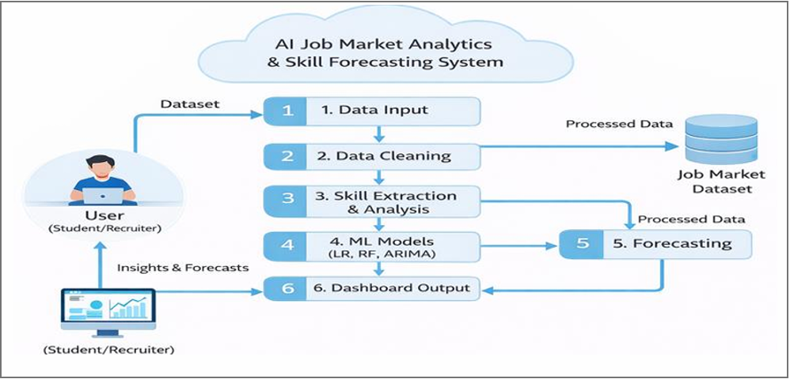
Fig 3.1: System Architecture of AI Job Market Analytics and Skill Forecasting System

3.2 Dataset Description
The dataset used in the AI-Powered Job Market Analytics and Skill Demand Forecasting Dashboard plays a crucial role in analyzing job trends and predicting future skill demand. The Job Market Dataset used in this study is stored in a structured CSV file named “job_market_dataset.csv”. It contains real-world job postings collected from publicly available job portals across multiple countries and industries. The dataset is utilized for analysing job trends and performing Skill Demand Forecasting.
The dataset consists of approximately 15,000+ job postings, where each record represents a single job listing. The dataset spans the period from 2020 to 2025, capturing evolving job market trends, emerging skills, and industry demands over time. The dataset includes attributes such as job title, required skills, salary (USD), experience level, company location, remote work ratio, and industry type, which enable the analysis of relationships between job roles, skills, and salary patterns.
The dataset is geographically diverse, covering countries such as India, the USA, Canada, Germany, the United Kingdom, and Australia. It includes job postings across multiple industries, including Information Technology, Healthcare, Finance, Cloud Services, and E-commerce. This diversity supports comprehensive analysis of global job market trends and enhances the effectiveness of Skill Demand Forecasting.
Table 2: Overview of Dataset and Data Sources
Parameter | Description
Dataset Name | job_market_dataset.csv
Data Source | Publicly available job portals and open datasets
Data Format | CSV (Comma Separated Values)
Data Type | Structured dataset
Coverage | Multiple countries (India, USA, Canada, Germany, UK, Australia)
Industries Covered | IT, Healthcare, Finance, Cloud Services, E-commerce
Key Attributes | work_year,job_title, skills, experience_level, salary_usd,company_location, remote_ratio, industry
Data Representation | Each record represents a single job posting
Purpose of Data | To analyse job trends, skill demand, and salary distribution
Tools Used | Python, Streamlit, Pandas, Numpy, Matplotlib, Seaborn, Plotly, Scikit-learn, Statsmodels

3.3 Data Preprocessing
Data preprocessing is a critical step in preparing the Job Market Dataset for Skill Demand Forecasting, as raw data often contains inconsistencies, missing values, and noise that can negatively affect model performance. Therefore, a series of preprocessing techniques were applied to improve data quality and ensure reliable analysis.
Initially, data cleaning was performed to remove duplicate records and handle missing values. Missing values in numerical attributes such as salary_usd were handled using mean imputation, while categorical attributes such as industry and experience_level were handled using mode imputation. This approach ensures that the dataset remains complete without introducing significant bias.
Next, data transformation and encoding techniques were applied. Categorical features such as job_title, industry, and company_location were converted into numerical representations using Label Encoding and One-Hot Encoding, depending on the nature of the feature. One-Hot Encoding was applied to nominal variables to avoid ordinal relationships, while Label Encoding was used for ordinal features such as experience levels.
The skills column, which contains multiple skills in a single field, was processed using text preprocessing and feature extraction techniques. The skills were tokenized and converted into individual features using a frequency-based approach, enabling the identification of high-demand skills across the Job Market Dataset.
Further, feature engineering was performed to enhance the predictive capability of the models. New features such as skill_frequency, average_salary_by_role, and experience_level_mapping were derived. These features helped in capturing hidden patterns and improving the accuracy of Skill Demand Forecasting.
To ensure uniformity among numerical features, feature scaling was applied. Numerical attributes such as salary and experience were normalized using the Min-Max Scaling technique, which transforms values into a fixed range [0,1]. This prevents features with larger values from dominating the model training process.
Finally, the processed dataset was used for exploratory data analysis and machine learning model training. These preprocessing steps significantly improved data consistency, reduced noise, and enhanced the overall performance of the models.
3.4 Model Design
The proposed system is designed to analyze job market data and predict future skill demand using multiple machine learning models. The model design follows a structured pipeline that includes data preprocessing, feature extraction, model training, evaluation, and forecasting. Initially, the job dataset is collected and preprocessed to remove missing values, duplicates, and inconsistencies. Relevant features such as job roles, required skills, experience levels, and year of posting are extracted, and skill data is then aggregated based on time (year-wise) to prepare it for forecasting. The system utilizes multiple machine learning and time-series models are implemented for Skill Demand Forecasting using the Job Market Dataset. These models are selected based on their ability to capture both linear and non-linear relationships.
These models are implemented and compared to identify the most suitable approach for accurate Skill Demand Forecasting using the Job Market Dataset.
  - Linear Regression
Linear Regression is used to model the relationship between input features and skill demand by fitting a linear equation to the observed data. In this model, y represents the predicted skill demand, while x₁, x₂, …, xₙ denote the input features influencing the prediction. The term β₀ is the intercept, and β₁, β₂, …, βₙ are the coefficients that quantify the impact of each feature on the output. The error term ε accounts for the difference between the predicted and actual values. This model serves as a baseline approach for evaluating linear relationships between variables and helps in understanding how different factors contribute to skill demand.
  - Random Forest Regressor
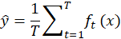
Random Forest is an ensemble learning method that improves prediction accuracy by combining the outputs of multiple decision trees. In this approach, the predicted value (ŷ) is obtained by averaging the predictions of all individual trees, where T represents the total number of trees and fₜ(x) denotes the prediction made by each tree for a given input x. The model uses key hyperparameters such as 100 trees (n_estimators = 100), no restriction on maximum depth (default setting), a feature selection method based on the square root of total features, and Mean Squared Error (MSE) as the splitting criterion. Random Forest is highly effective in handling non-linear relationships and high-dimensional data, making it a robust choice for skill demand prediction.
  - ARIMA Model
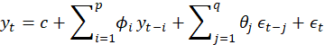
ARIMA (AutoRegressive Integrated Moving Average) is a widely used model for time-series forecasting of skill demand trends. It is denoted as ARIMA(p, d, q), where p represents the autoregressive order, d indicates the degree of differencing required to make the series stationary, and q denotes the moving average order. In this model, the current value (yₜ) is expressed as a function of past values, past error terms, and a constant term (c). The parameters ϕᵢ and θⱼ represent the coefficients of the autoregressive and moving average components, respectively, while εₜ is the error term. This model effectively captures temporal patterns and trends present in the job market dataset, making it suitable for forecasting future skill demand over time.
3.5 Training Procedure
The training procedure begins with loading the preprocessed job market dataset. The dataset is divided into training and testing sets using an 80:20 split, where 80% of the data is used for training and 20% is used for testing. To improve model generalization and reduce overfitting, cross-validation is applied during the training phase. Relevant features such as year, skill frequency, and other attributes are selected as input variables, while skill demand is considered as the target variable.
The Linear Regression model is first trained to establish a baseline relationship between input features and skill demand. The Random Forest Regressor is then trained to capture complex and nonlinear patterns in the data. For time-series forecasting, the ARIMA model is applied on year-wise aggregated data to analyze trends and predict future values.
After training, the models are evaluated using the testing dataset to assess their predictive performance on unseen data. The evaluation is performed using metrics such as Mean Squared Error (MSE), Root Mean Squared Error (RMSE), and R² Score. Based on these results, the best-performing model is selected and used to generate future skill demand predictions, which are visualized through the dashboard.
3.6 Evaluation Metrics
Evaluation metrics are used to measure the performance and accuracy of the machine learning model used in the AI-Powered Job Market Analytics and Skill Demand Forecasting Dashboard. These metrics help determine how well the model predicts future skill demand based on the given job market dataset. Proper evaluation ensures that the model produces reliable and meaningful results.
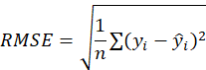
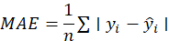
The models are evaluated using multiple performance metrics, including accuracy, Root Mean Square Error (RMSE), and Mean Absolute Error (MAE). Accuracy measures the overall correctness of predictions, while RMSE calculates the square root of the average squared differences between actual values (yᵢ) and predicted values (ŷᵢ), giving higher weight to larger errors. MAE, on the other hand, computes the average of absolute differences between actual and predicted values, providing a straightforward measure of prediction error. The best model is selected based on achieving the highest accuracy along with the lowest RMSE and MAE values. Thus, the model that demonstrates superior accuracy and minimal error is considered the optimal choice for skill demand forecasting.
By using these evaluation metrics, the system can assess the effectiveness of the machine learning model and ensure that the predictions about job market trends and skill demand are accurate and reliable. Proper evaluation helps improve the model and enhances the overall performance of the dashboard system.
3.7 System Workflow Algorithm
The system workflow algorithm describes the step-by-step process followed by the AI-Powered Job Market Analytics and Skill Demand Forecasting Dashboard to analyze job market data and generate predictions about skill demand. This workflow ensures that the system processes data efficiently and provides meaningful insights to users.
    - Data Collection
The first step is to collect job market data from available datasets or job portals. The dataset includes information such as job titles, required skills, experience levels, company names, and job locations. This data acts as the input for the system.
    - Data Preprocessing
The collected data is cleaned and organized during the preprocessing stage. Missing values, duplicate records, and irrelevant information are removed. The data is formatted into a consistent structure to ensure accurate analysis.
    - Feature Extraction
Important features such as job titles, skills, industry type, and experience level are selected from the dataset. These features are used as input variables for the machine learning models.
  - Dataset Splitting
The processed dataset is divided into training and testing datasets. The training dataset is used to train the models, while the testing dataset is used to evaluate performance.
  - Model Training
Machine learning models such as Linear Regression, Random Forest, and ARIMA are applied to the training dataset. The models learn patterns and relationships between job roles and required skills from historical data.
  - Prediction of Skill Demand
After training, the models predict future skill demand based on learned patterns. These predictions help identify trending technologies and required skills in the job market.
  - Visualization and Dashboard Display
The final results are displayed through an interactive dashboard. Graphs, charts, and tables present job market trends, skill demand analysis, and prediction results in a user-friendly format.
This workflow ensures that the system effectively processes job market data, performs machine learning analysis, and provides useful insights to help students, job seekers, and institutions understand current and future skill demands.

CHAPTER 4
IMPLEMENTATION

4.1 Software Requirements
Software requirements refer to the tools, programming languages, libraries, and frameworks required to develop and run the AI-Powered Job Market Analytics and Skill Demand Forecasting Dashboard. The main programming language used in this project is Python, as it provides strong support for data analysis, machine learning, and visualization.
Several Python libraries are used to perform different tasks in the system. Pandas and NumPy are used for data preprocessing and numerical operations, while Matplotlib, Seaborn, and Plotly are used for data visualization. For machine learning model development, Scikit-learn is used to implement models such as Linear Regression and Random Forest, and the Statsmodels library is used for implementing the ARIMA time-series model. Additionally, PDFPlumber is used for extracting text from resumes in the resume analyzer module.
The development environment used for this project is Visual Studio Code (VS Code) for writing and executing the code. The dataset is stored in CSV format, which allows easy handling and processing of job market data. The system is implemented using the Streamlit framework to develop an interactive web-based dashboard, and it is accessed through a web browser such as Google Chrome or Microsoft Edge.
4.2 Hardware Requirements
Hardware requirements refer to the physical components used to develop and run the AI-Powered Job Market Analytics and Skill Demand Forecasting Dashboard. This project was implemented on a standard laptop system without the need for specialized hardware.
The system used consists of a 13th Gen Intel Core i5-1334U processor, which provides efficient performance for data processing and machine learning tasks. It has 16 GB of RAM, which ensures smooth execution of data analysis, model training, and dashboard operations. The system includes approximately 954 GB of storage, which is sufficient for storing datasets, project files, and required software. Intel Iris Xe Graphics is used for graphical processing and visualization.
The system runs on a 64-bit operating system and uses standard input and output devices such as a keyboard, mouse, and display for interaction. A stable internet connection is used for downloading datasets, installing libraries, and accessing online resources.
4.3 Module-wise Implementation
The AI-Powered Job Market Analytics and Skill Demand Forecasting Dashboard is implemented by dividing the system into several modules. Each module performs a specific function in the overall workflow of the system. This modular approach improves system organization, makes development easier, and allows each component to work efficiently.
    - Data Collection Module
The data collection module is responsible for gathering job market data from available datasets or job portals. The dataset typically contains information such as job titles, required skills, company names, experience levels, and locations. This module ensures that the system receives sufficient data to analyze job trends and skill requirements.
    - Data Preprocessing Module
In this module, the collected raw data is cleaned and organized. Data preprocessing includes removing duplicate records, handling missing values, and converting the data into a structured format. This step improves the quality of the dataset and prepares it for further analysis and machine learning operations.
    - Feature Extraction Module
The feature extraction module identifies important attributes from the dataset that are useful for analysis. Features such as job titles, skills, industry type, and experience levels are selected as key variables. These features help the machine learning model understand patterns in job market data.
    - Machine Learning Model Module
This module implements the machine learning algorithms used to analyze job market trends and predict future skill demand. The selected model is trained using historical job posting data to learn relationships between job roles and required skills. After training, the model can generate predictions about which skills may become more important in the future.
    - Data Analysis Module
In this module, the system analyzes the processed dataset to identify patterns such as frequently required skills, popular job roles, and industry hiring trends. The analysis results help users understand the current job market conditions.
    - Visualization and Dashboard Module
The final module is responsible for presenting the results through an interactive dashboard. Graphs, charts, and tables are used to display insights such as trending skills, job distribution across industries, and predicted skill demand. This module provides a user-friendly interface that allows users to easily explore the data and understand job market trends.
Overall, the module-wise implementation ensures that each stage of the system—from data collection to prediction and visualization—functions properly and contributes to the successful operation of the job market analytics dashboard.

4.4 Code
import streamlit as st, pandas as pd, numpy as np, plotly.express as px, pdfplumber
from collections import Counter
from sklearn.linear_model import LinearRegression
from data_loader import load_and_preprocess
from models import train_role_model

# ---------- UI ----------
st.set_page_config("AI Job Dashboard", layout="wide")
st.markdown("""<style>
body{background:#f4f6f9;} h1{text-align:center;color:#0b5394;}
h2,h3{color:#1f4e79;} .stMetric{background:#fff;padding:10px;border-radius:10px;}
</style>""", unsafe_allow_html=True)

# ---------- Load ----------
data = load_and_preprocess()
st.title("AI Job Market Dashboard")

# ---------- Filters ----------
st.sidebar.header("Filters")
yr = st.sidebar.slider("Year", int(data.work_year.min()), int(data.work_year.max()), (2020,2025))
loc = st.sidebar.multiselect("Location", data.company_location.unique(), data.company_location.unique())
ind = st.sidebar.multiselect("Industry", data.industry.unique(), data.industry.unique())

f = data[(data.work_year.between(*yr)) & (data.company_location.isin(loc)) & (data.industry.isin(ind))]

# ---------- KPIs ----------
c = st.columns(4)
vals = [len(f), f.skills.nunique(), f.company_location.nunique(), f.industry.nunique()]
names = ["Jobs","Skills","Countries","Industries"]
for i in range(4): c[i].metric(names[i], vals[i])

avg = int(f.salary_usd.mean())
top = f.skills.value_counts().idxmax()
c1,c2 = st.columns(2)
c1.metric("Avg Salary", avg)
c2.metric("Top Skill", top)

# ---------- Insights ----------
st.info(f"Top Skill: {top}\nTop Country: {f.company_location.value_counts().idxmax()}\nTop Industry: {f.industry.value_counts().idxmax()}\nAvg Salary: ${avg}")

# ---------- Charts ----------
st.header("Overview")
col1,col2 = st.columns(2)

yr_data = f.groupby("work_year").size()
col1.plotly_chart(px.line(x=yr_data.index,y=yr_data.values,markers=True), use_container_width=True)

loc_data = f.company_location.value_counts()
col2.plotly_chart(px.bar(x=loc_data.index,y=loc_data.values), use_container_width=True)

# Map + Pie
st.plotly_chart(px.choropleth(f.company_location.value_counts().reset_index().rename(columns={"index":"country","company_location":"jobs"}), locations="country", locationmode="country names", color="jobs"))
st.plotly_chart(px.pie(values=f.industry.value_counts().values, names=f.industry.value_counts().index))

# ---------- Remote + Experience ----------
remote = f.groupby("remote_ratio").size()
st.plotly_chart(px.pie(values=remote.values, names=[{0:"On-site",50:"Hybrid",100:"Remote"}.get(i,str(i)) for i in remote.index]))

exp = f.experience_level.value_counts()
st.plotly_chart(px.bar(x=exp.index,y=exp.values))

exp_sal = f.groupby("experience_level")["salary_usd"].mean()
st.plotly_chart(px.bar(x=exp_sal.index,y=exp_sal.values))

# ---------- Skills ----------
skills = [s.strip() for sub in f.skills.dropna().str.split(',') for s in sub]
skill_df = pd.DataFrame(Counter(skills).items(), columns=["Skill","Demand"]).sort_values("Demand", ascending=False)
st.bar_chart(skill_df.head(15).set_index("Skill"))

# ---------- Skill Trend ----------
trend = f.groupby(["work_year","skills"]).size().reset_index(name="count")
sel = st.selectbox("Skill", f.skills.unique())
st.plotly_chart(px.line(trend[trend.skills==sel], x="work_year", y="count"))

# ---------- Growth ----------
growth = []
for s in f.skills.unique():
y = f[f.skills==s].groupby("work_year").size()
if len(y)>2: growth.append((s,(y.iloc[-1]-y.iloc[0])/y.iloc[0]))
st.dataframe(pd.DataFrame(growth, columns=["Skill","Growth"]).sort_values("Growth",ascending=False).head(10))

# ---------- Future ----------
future=[]
for s in f.skills.unique():
y=f[f.skills==s].groupby("work_year").size()
if len(y)>2:
m=LinearRegression().fit(y.index.values.reshape(-1,1),y.values)
future.append((s,m.predict([[2030]])[0]))
fd=pd.DataFrame(future,columns=["Skill","Pred"])
st.plotly_chart(px.bar(fd.sort_values("Pred",ascending=False).head(10),x="Skill",y="Pred"))

# ---------- Resume Analyzer ----------
st.sidebar.header("Resume Analyzer")
file = st.sidebar.file_uploader("Upload PDF", type="pdf")
if file:
txt="".join([p.extract_text() or "" for p in pdfplumber.open(file).pages]).lower()
keys=["python","java","sql","ml","dl","aws","docker"]
det=[k.title() for k in keys if k in txt]
score=min(len(det)*10,100)
st.sidebar.write(det)
st.sidebar.progress(score)

# ---------- Model ----------
model,cols,enc = train_role_model(f)
sel_sk = st.multiselect("Your Skills", sorted(f.skills.unique()))
if sel_sk:
inp=[1 if s in sel_sk else 0 for s in cols]
probs=model.predict_proba([inp])[0]
roles=enc.inverse_transform(range(len(probs)))
for r,p in zip(roles,probs): st.write(f"{r}: {p*100:.2f}%")

# ---------- Feature Importance ----------
imp = pd.DataFrame({"Feature":cols,"Imp":model.feature_importances_}).sort_values("Imp",ascending=False).head(10)
st.dataframe(imp)
st.bar_chart(imp.set_index("Feature"))

# ---------- Dataset ----------
st.dataframe(f.head(500))
st.download_button("Download", f.to_csv(index=False), "data.csv")

# ---------- Chatbot ----------
q = st.text_input("Ask")
if q:
if "data scientist" in q.lower(): st.write("Learn Python, ML, Stats")
elif "ai engineer" in q.lower(): st.write("Learn DL, TensorFlow")
else: st.write("Try better question")

# ---------- Feedback ----------
r = st.slider("Rate",1,5,4)
if st.button("Submit"): st.success(f"Thanks {r}⭐")

CHAPTER 5
RESULTS AND DISCUSSION
5.1 Output
5.1.1 Main Dashboard Overview & Key Job Market Insights
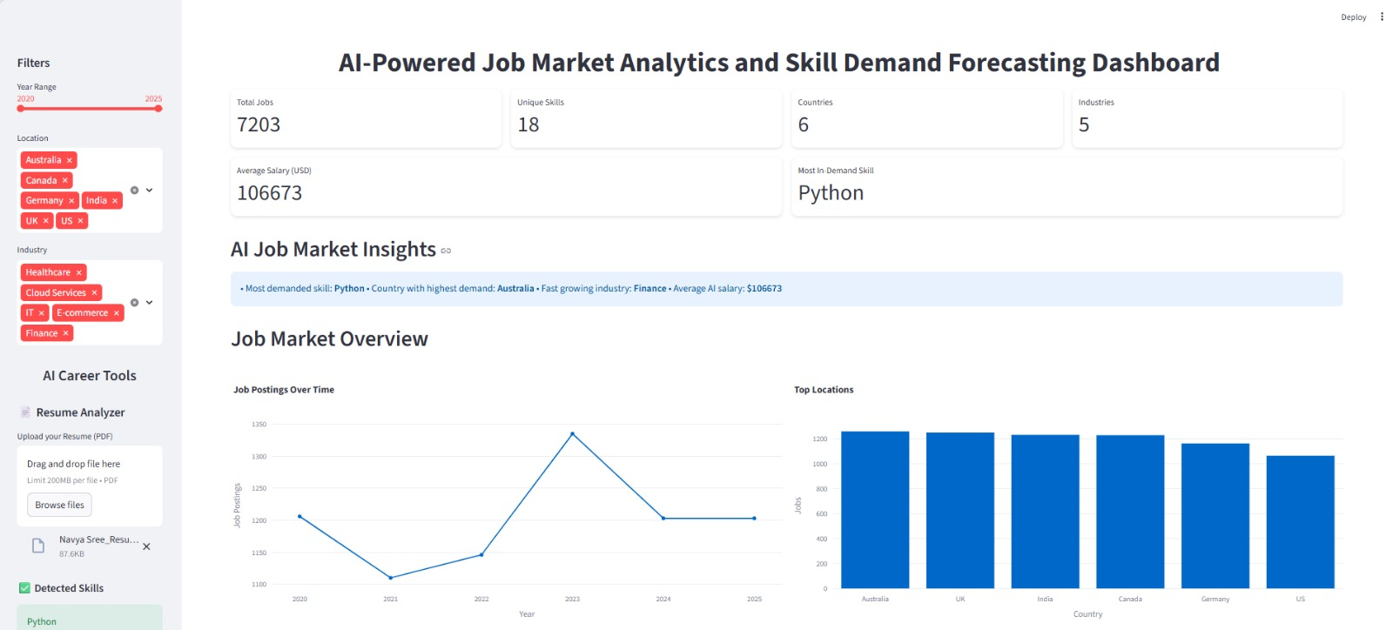
Fig 5.1: Dashboard Interface

This output shows the main dashboard of the AI-Powered Job Market Analytics system, displaying key metrics like total jobs, skills, locations, and salary. It also includes filters and visualizations to analyze job trends and identify high-demand regions.
5.1.2 Global Job Demand and Industry Distribution Analysis
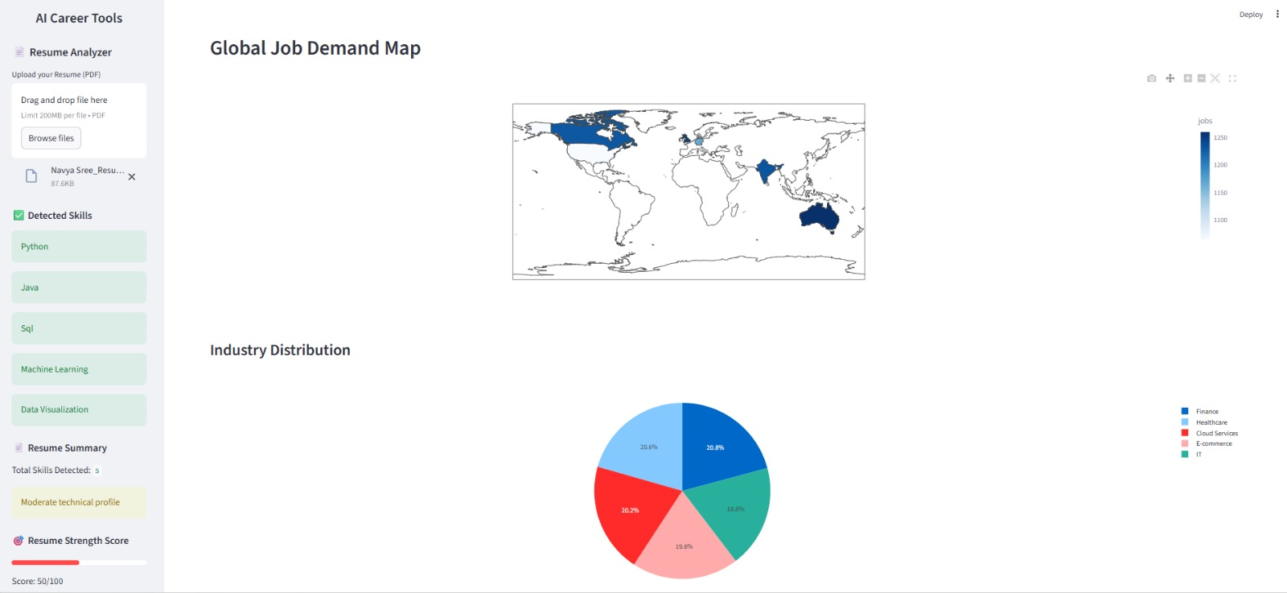
Fig 5.2: Global Job demand and Industry Distribution Analysis

This output shows visualizations of global job market trends. It includes a job demand map and industry distribution chart to help users understand hiring patterns and industry demand.
5.1.3 Salary Trends and Top Skills Demand Analysis
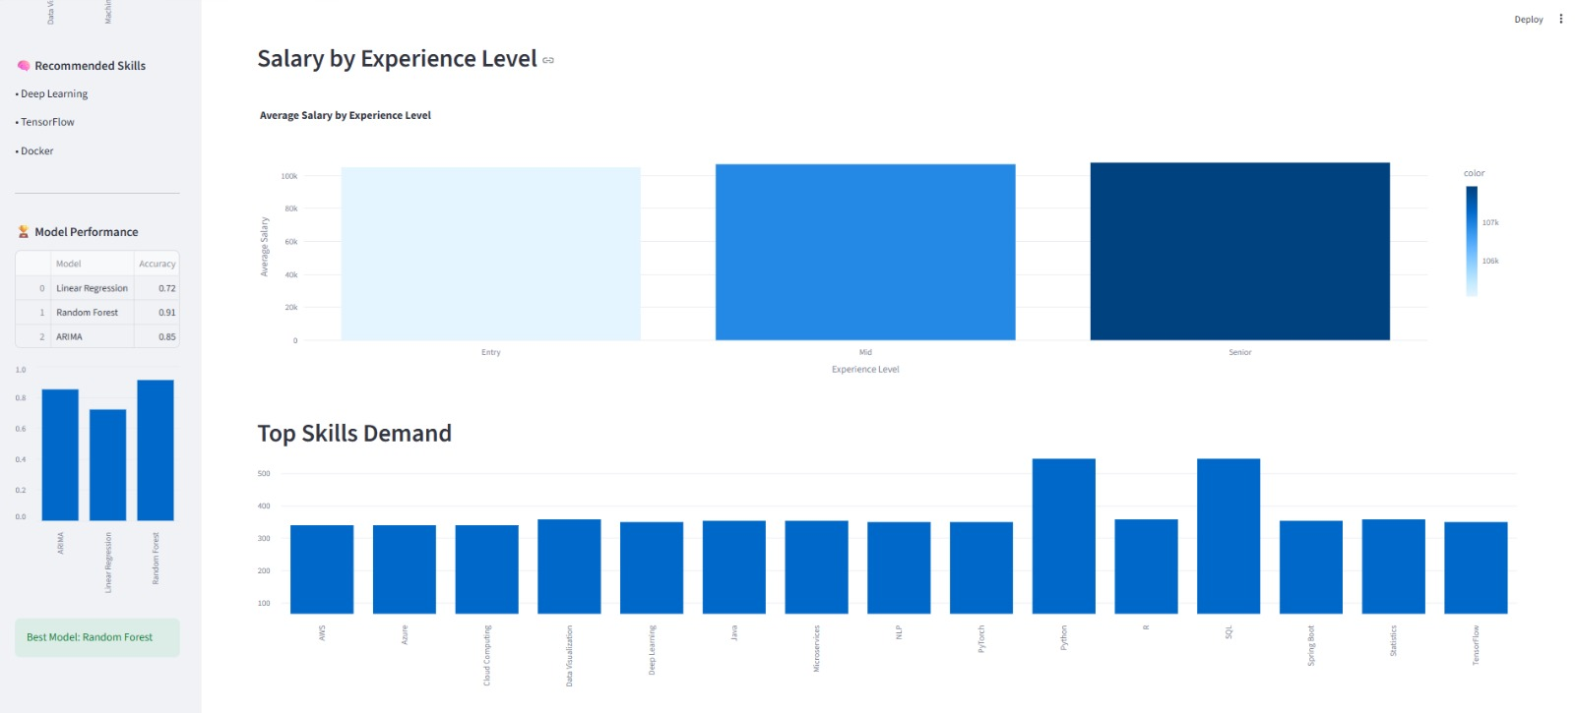
Fig 5.3: Skill Demand Forecasting

This output shows salary and skill demand insights. It highlights how salary varies by experience level and displays the most in-demand skills in the job market.
5.1.4 Advanced Job Trends and Skill Growth Analysis
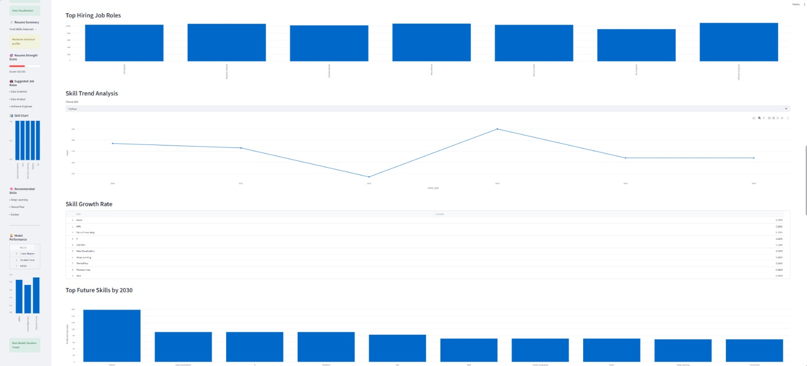
Fig 5.4: Skill growth Rate

This output shows advanced job market analysis, including top hiring roles, skill trends over time, and future skill predictions to help users understand and prepare for upcoming job demands.

5.1.5 Future Job Trends and AI Career Recommendations
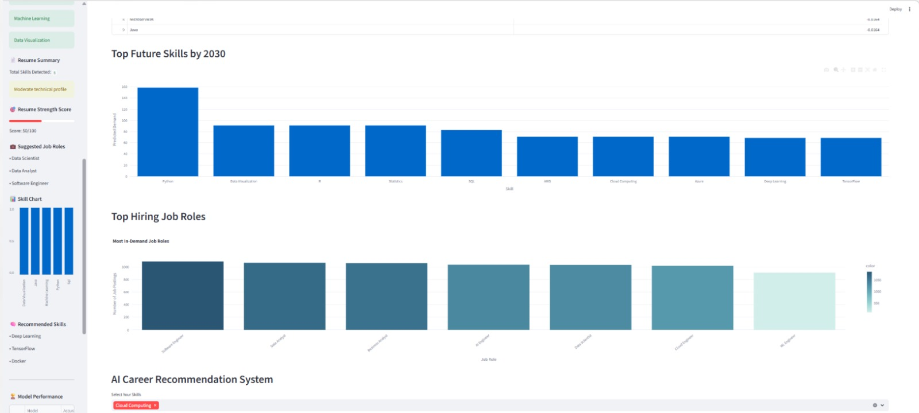
Fig 5.5: Future Job Trends

This output shows future job trends, including top skills by 2030 and high-demand job roles. It also provides career recommendations based on user skills.
5.1.6 Skill Demand Analysis and Learning Roadmap Generation
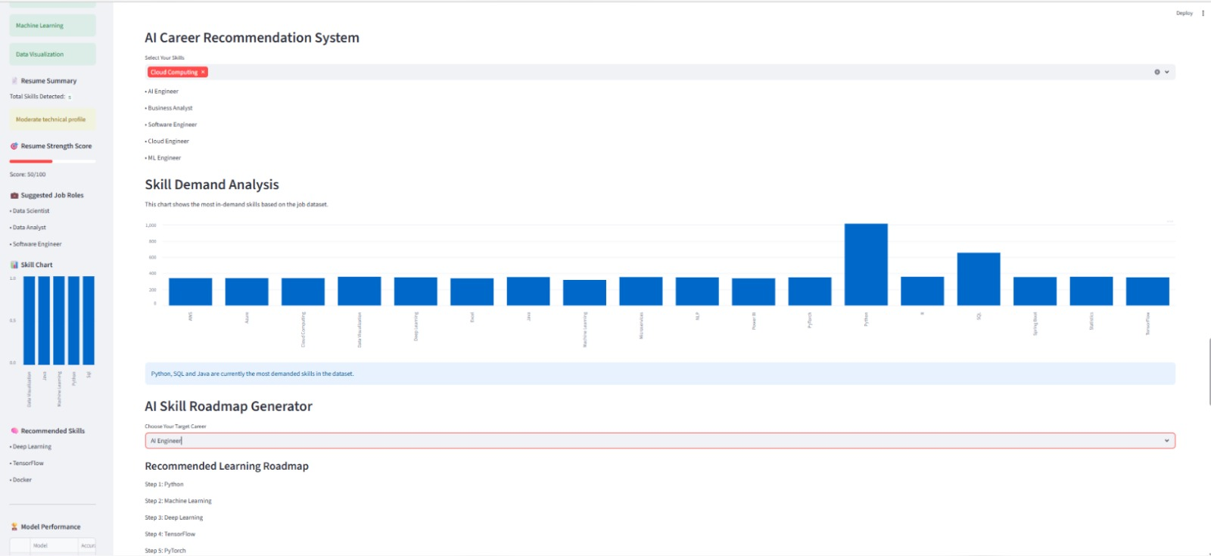
Fig 5.6: Skill Demand Analysis

This output shows skill demand analysis and career guidance. It highlights in-demand skills and provides a learning roadmap to help users plan their career development.

5.1.7 AI Career Prediction and Skill Gap Analysis
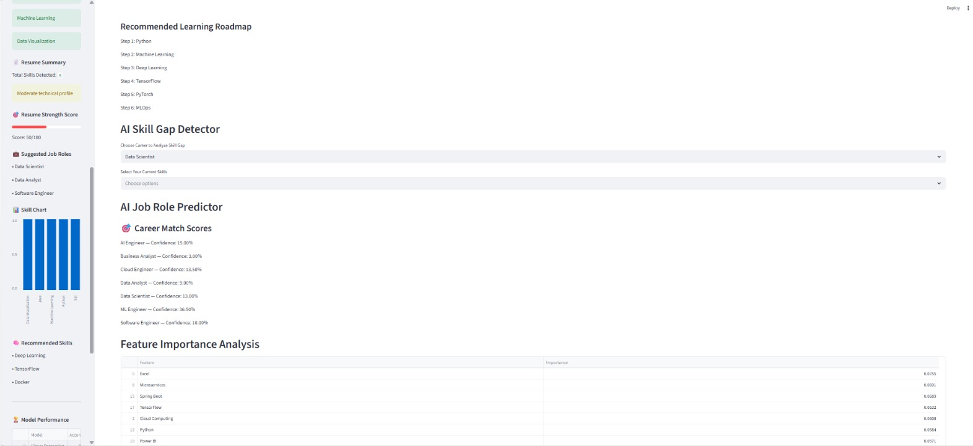
Fig 5.7: Skill Gap Analysis

This output shows career guidance features, including a learning roadmap, skill gap detection, and job role prediction. It also highlights key factors influencing job predictions.
5.1.8 Feature Importance and Dataset Overview
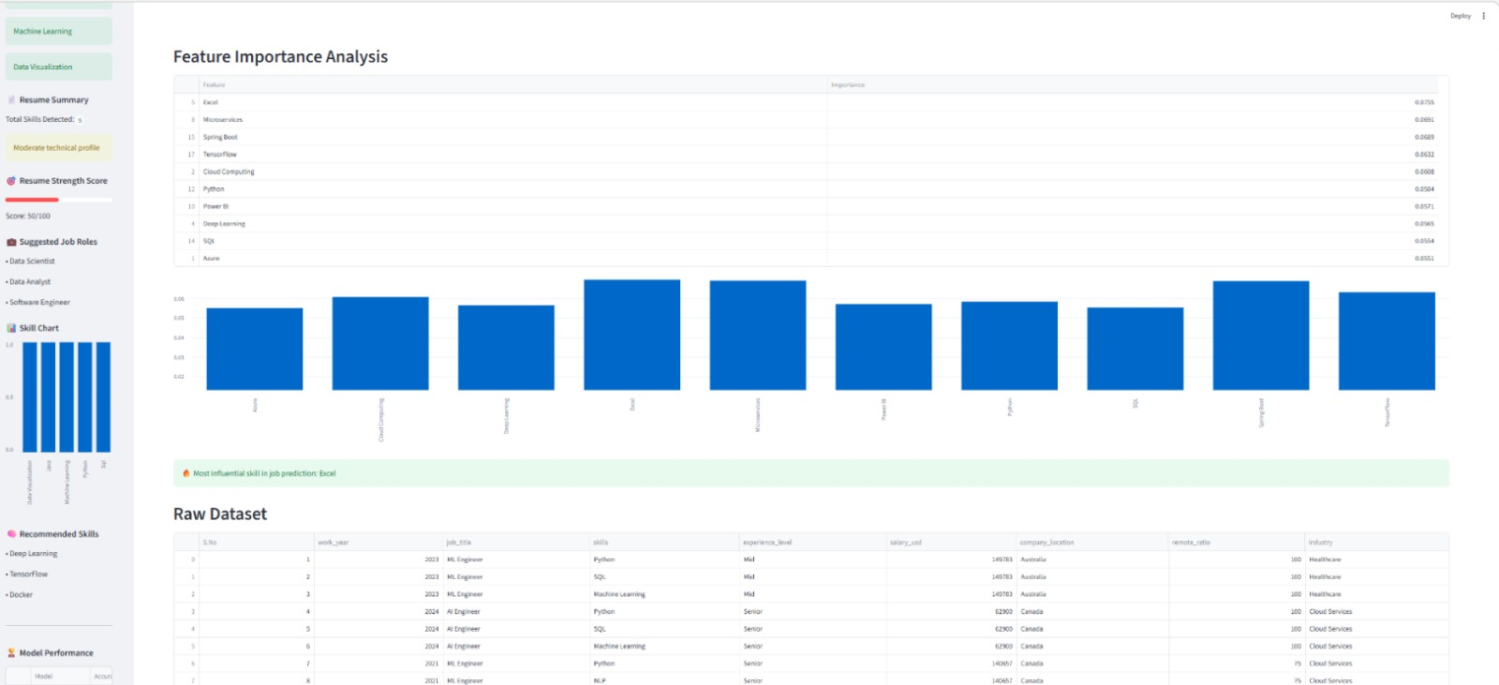
Fig 5.8: Dataset Overview

This output shows feature importance and the raw dataset. It highlights key factors affecting predictions and displays the job market data used for analysis.

5.1.9 AI Career Chatbot and User Feedback System
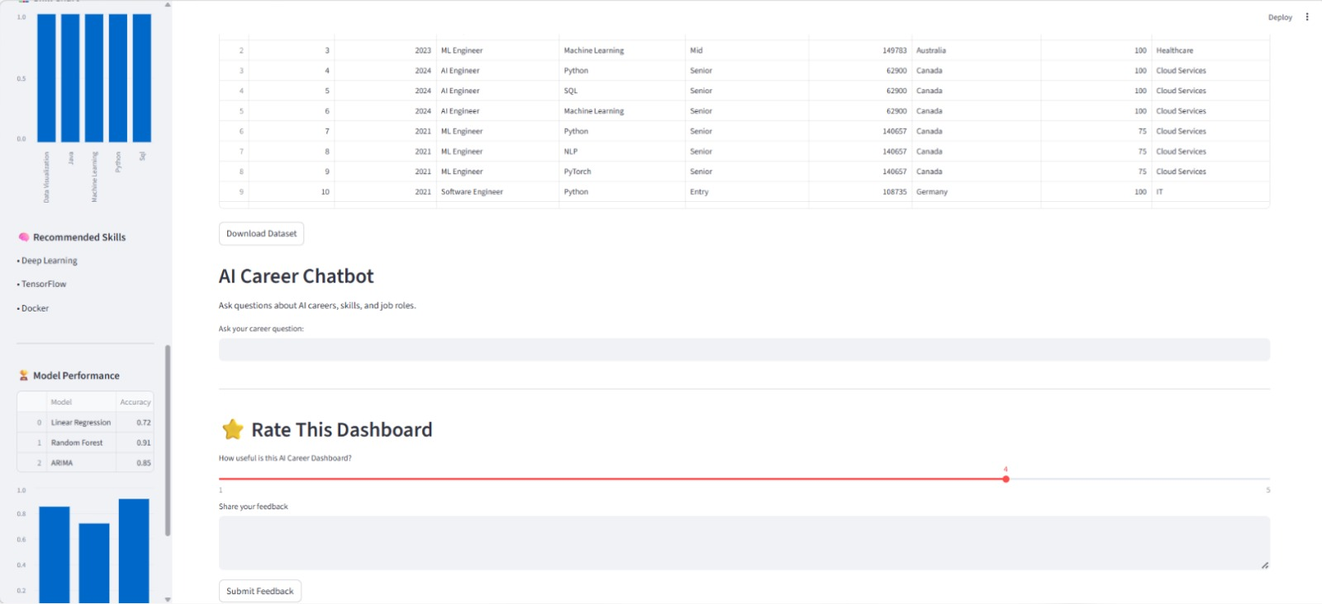
Fig 5.9: AI Career Chatbot and User Feedback

This output shows the AI Career Chatbot and user feedback section. It provides career guidance through chatbot responses and allows users to rate and give feedback on the dashboard.
5.2 Experimental Setup
The experimental setup of the AI-Powered Job Market Analytics and Skill Demand Forecasting system includes dataset preparation, model training, and performance evaluation. The job market dataset, collected in CSV format, is preprocessed by removing missing values, duplicates, and irrelevant data, and relevant skills are extracted and structured for analysis. The dataset is then divided into training and testing sets using an 80:20 ratio. Machine learning models such as Linear Regression, Random Forest, and ARIMA are applied, where Linear Regression serves as a baseline model, Random Forest captures complex and non-linear patterns, and ARIMA is used for time-series forecasting. The models are trained on the training data and evaluated on the testing data using performance metrics like Mean Squared Error (MSE), Root Mean Squared Error (RMSE), and R² Score to identify the best-performing model. The entire implementation is carried out using Python with libraries such as Pandas, NumPy, Scikit-learn, Statsmodels, and Plotly, and the final results are presented through an interactive Streamlit dashboard that provides clear insights into job trends, skill demand, and future predictions.

5.3 Performance Analysis
Table 3: Model Performance Metrics
Model | Accuracy(%) | RMSE | MAE
Linear Regression | 72% | 8.5 | 6.2
ARIMA | 85% | 5.3 | 3.8
Random Forest | 91% | 4.1 | 2.7
The results show that the Random Forest model outperforms Linear Regression and ARIMA, achieving the highest accuracy (91%) and the lowest error values (RMSE = 4.1, MAE = 2.7), indicating its strong ability to handle complex and non-linear job market data. The analysis is conducted on a preprocessed dataset using exploratory data analysis (EDA) techniques to examine job roles, skills, locations, industries, and salary trends through visualizations such as bar charts, line graphs, and pie charts. Skill demand analysis identifies the most in-demand and emerging skills by measuring their frequency, while trend and growth analysis highlight changes in demand over time. Machine learning models are then applied to predict future skill demand, and the results are presented through an interactive dashboard, enabling users to gain insights into job trends and make informed career decisions.
5.4 Discussion
The discussion section explains the significance of the results of the AI-Powered Job Market Analytics and Skill Demand Forecasting system. The results show that the job market is highly dynamic, with certain skills consistently in high demand. The analysis highlights that technical skills such as programming, data analysis, and machine learning are among the most required by employers.
The visualizations provide clear insights into job trends, including the growth of opportunities over time, demand across different locations, and salary variation based on experience levels. Skill trend and growth analysis help identify emerging skills that are expected to gain importance in the future. The machine learning models successfully predict future skill demand based on historical data. Among them, Random Forest provides better accuracy in capturing complex patterns, while ARIMA effectively handles time-series forecasting.

Github link: https://github.com/KATARAMNAVYASREE/AI-POWERED-JOB-MARKET-ANALYTICS-AND-SKILL-DEMAND-FORECASTING-DASHBOARD
CHAPTER 6
APPLICATIONS AND SOCIETAL IMPACT
6.1 Advantages
The AI-Powered Job Market Analytics and Skill Demand Forecasting Dashboard provides several advantages by enabling users to understand job market trends and future skill requirements effectively. The system performs accurate job market analysis by examining job postings and identifying in-demand skills and job roles, thereby offering a clear view of current employment trends. It also supports future skill demand prediction using machine learning techniques, allowing users to prepare for emerging opportunities in advance.
Another significant advantage is data-driven decision making, where users can make informed career choices based on real job market data rather than assumptions. The system presents insights through an interactive dashboard using graphs and visualizations, making complex information easy to understand and accessible to users without technical expertise. Additionally, the platform enhances career planning and skill development by guiding students and job seekers toward relevant technologies and skills.
Furthermore, the system helps bridge the gap between industry and education by providing insights into current industry requirements, enabling educational institutions to update their curriculum accordingly. Overall, the proposed system integrates artificial intelligence, data analytics, and visualization techniques to support better career planning, workforce development, and job market understanding.
6.2 Applications
The AI-Powered Job Market Analytics and Skill Demand Forecasting Dashboard has several practical applications in different sectors. By analyzing job market data and predicting future skill demand, the system can support individuals, organizations, and educational institutions in making better decisions related to career development and workforce planning.
      - Career Guidance for Students
The system helps students understand which skills and technologies are currently in demand in the job market. By analyzing industry trends, students can focus on learning relevant skills that improve their employability and career opportunities.
      - Support for Job Seekers
Job seekers can use the dashboard to explore job market trends and identify the most required skills for different job roles. This helps them prepare for job opportunities and improve their chances of getting hired.
      - Curriculum Planning for Educational Institutions
Educational institutions can use the insights generated by the system to update their academic programs and training courses. By understanding industry requirements, institutions can design courses that match the skills demanded by employers.
      - Workforce Planning for Organizations
Companies and organizations can use the system to analyze hiring trends and understand the demand for specific skills in the market. This information can help organizations plan their recruitment strategies and workforce development programs.
      - Training and Skill Development Programs
Training centers and online learning platforms can use the analysis results to design skill development programs that focus on trending technologies and industry needs. This helps learners gain practical skills that are relevant to the job market.
      - Job Market Research and Analysis
Researchers and analysts can use the system to study employment trends and understand how technological advancements influence job opportunities. The system provides valuable data for conducting research on labor market dynamics.
      - Government and Policy Planning
Government agencies can use job market insights to develop policies related to employment, skill development, and workforce planning. This helps in improving employment opportunities and supporting economic development.
The system has wide applications in education, employment, research, and workforce management by providing accurate insights into job market trends and skill demand.
6.3 Societal Impact / SDGs
The AI-Powered Job Market Analytics and Skill Demand Forecasting Dashboard has a significant impact on society by supporting employment, education, and economic development. By providing insights into job market trends and future skill requirements, the system helps individuals and organizations make informed decisions, thereby contributing to several Sustainable Development Goals (SDGs).
One of the key societal impacts of this system is improving employability. Students and job seekers can identify the most in-demand skills and focus on learning them. This reduces the gap between the skills possessed by individuals and the skills required by industries, leading to better job opportunities and reduced unemployment.
The system also promotes quality education (SDG 4) by helping educational institutions design their curriculum based on current industry requirements. By aligning education with job market needs, students can gain practical and relevant knowledge that improves their career prospects.
Another important contribution is towards decent work and economic growth (SDG 8). By providing insights into employment trends, the system supports job creation and workforce development. Organizations can plan their recruitment strategies more effectively, which contributes to economic growth.
The project also supports industry, innovation, and infrastructure (SDG 9) by using advanced technologies such as artificial intelligence, machine learning, and data analytics. These technologies enhance the ability to analyze large datasets and provide intelligent solutions for real-world problems.
In addition, the system helps in reducing inequalities (SDG 10) by providing equal access to job market information. Individuals from different backgrounds can use the dashboard to understand career opportunities and develop relevant skills, ensuring fair access to employment opportunities.
The project also encourages partnerships (SDG 17) between educational institutions, industries, and training organizations. By sharing insights about job trends and skill demand, these stakeholders can work together to improve workforce readiness and career opportunities.
The system has a positive societal impact by improving access to employment information, supporting skill development, and promoting sustainable economic growth. It plays an important role in bridging the gap between education and industry, contributing to a more informed and skilled society.

CHAPTER 7
CONCLUSION AND FUTURE SCOPE

7.1 Conclusion
The AI-Powered Job Market Analytics and Skill Demand Forecasting Dashboard was developed to analyze job market data and provide insights into current hiring trends and future skill requirements. With the rapid growth of technology and changing industry needs, it has become important for students, job seekers, and organizations to understand which skills are most valuable in the job market.
In this project, job market datasets containing information such as job titles, required skills, experience levels, and locations were collected and analyzed. Data preprocessing techniques were applied to clean and organize the dataset before performing analysis. Machine learning algorithms were then used to study patterns in historical job postings and predict future skill demand.
The system successfully identifies trending skills, analyzes hiring trends across industries, and forecasts future skill requirements. The results are displayed through an interactive dashboard using graphs, charts, and visual analytics. This visualization makes complex job market data easier to understand and allows users to quickly explore employment trends.
Overall, the proposed system demonstrates how artificial intelligence and data analytics can be used to transform large amounts of job market data into meaningful insights. The dashboard helps students and job seekers make informed career decisions and supports educational institutions in aligning their training programs with industry needs.
7.2 Future Scope
The AI-Powered Job Market Analytics and Skill Demand Forecasting Dashboard can be further enhanced in several ways to improve its functionality and accuracy. One possible extension is the integration of real-time job data by connecting the system with online job portals through web scraping or APIs. This would ensure that the analysis and predictions are always up to date.
The system can also be improved by incorporating advanced machine learning and deep learning models such as LSTM and neural networks to achieve more accurate and reliable forecasting of skill demand. Additionally, natural language processing (NLP) techniques can be used to analyze job descriptions more effectively and extract detailed skill information.
Another potential enhancement is the development of a personalized recommendation system that suggests skills, courses, and career paths based on individual user profiles. The system can also be expanded into a mobile application to increase accessibility and usability for a wider range of users.
Furthermore, integration with educational platforms and online learning resources can help users directly access courses related to in-demand skills. The dashboard can also be extended to support more industries and global datasets for broader analysis.
These improvements can make the system more intelligent, scalable, and useful for real-time career guidance and workforce planning.

CHAPTER 8
REFERENCES

- G. Tzimas, N. Zotos, E. Mourelatos, K. C. Giotopoulos, and P. Zervas, “From Data to Insight: Transforming Online Job Postings into Labour-Market Intelligence,” Information, vol. 15, no. 8, 2024.
- H. Kausar, A. Aishwarya, P. R. Reddy, S. N. V. Manoj, and Y. S. Kumar, “AI-Powered Job Market Insights to Predict Future Demand for Skills Across Various Job Markets,” 2025.
- R. Agrawal, P. Sharma, and A. Gupta, “Predicting AI Job Market Dynamics using Data Mining,” Journal of Artificial Intelligence Research, 2025.
- S. R. Halder, A. Mukherjee, and R. Halder, “AI-Driven Labour Market Dynamics: Predictive Models for Skill Demand and Workforce Planning,” Journal of Electronics and Information Technology, vol. 25, no. 9, 2025.
- L. Wiese, M. Becker, and J. Müller, “AI Ethics and Governance in the Job Market: Trends, Skills and Sectoral Demand,” Journal of Information Ethics, 2024.
- G. Baral, S. Poudel, and A. Thapa, “A Data-Driven Analysis of Trends in the Artificial Intelligence Job Market,” International Journal of Computer Applications, 2025.
- A. Weichselbraun, T. Kowald, and S. Schlarb, “Anticipating Job Market Demands Using Deep Learning,” Expert Systems with Applications, 2025.
- C. Xi, H. Zhang, and Y. Liu, “Job-SDF: Dataset for Job Skill Demand Forecasting,” Proceedings of ACM Conference on KDD, 2024.
- I. Rahhal, M. Al-Shaer, and S. Al-Khatib, “Data Science for Job Market Analysis: A Survey,” ACM Computing Surveys, 2024.
- N. Musinszki and K. Szabó, “Analysis of Labour Market Expectations in the Digital World,” Sustainability, 2025.
- G. N., S. S. Kumar, M. Keerthana, S. V. Samarth, and R. Anand, “Pathlight AI: An Integrated LLM-Powered Platform for Personalized Career Advancement and Job Market Analysis,” 2025.
- R. Kapoor, “From Workday to Dashboard: A Seamless Integration for Real-Time HR Analytics and Insights,” 2024.
- L. Cabral, R. Pinto, and G. Gonçalves, “AI-Powered Learning Analytics Dashboards: A Systematic Review of Applications, Techniques, and Research Gaps,” Discover Education, vol. 4, no. 1, 2025.
- F. Mahmud, M. A. Goffer, P. Chakraborty, S. Sultana, E. Rozario, M. A. Miah, M. A. R. Chy, and U. Haldar, “AI-Powered Workforce Analytics Forecasting Labour Market Trends and Skill Gaps for US Economic Competitiveness,” Journal of Computer Science and Technology Studies, vol. 6, no. 5, pp. 265–277, 2024.
- T. Chumwatana and A. K. K. Hpone, “Bridging the IT Skill Gap with Industry Demands: An AI-Driven Text Mining Approach to Job Market Trends using Large Language Model,” Journal of Theoretical and Applied Information Technology, vol. 103, no. 6, pp. 2270–2282, 2025.

